Saturday, February 02, 2013
7:37 PM

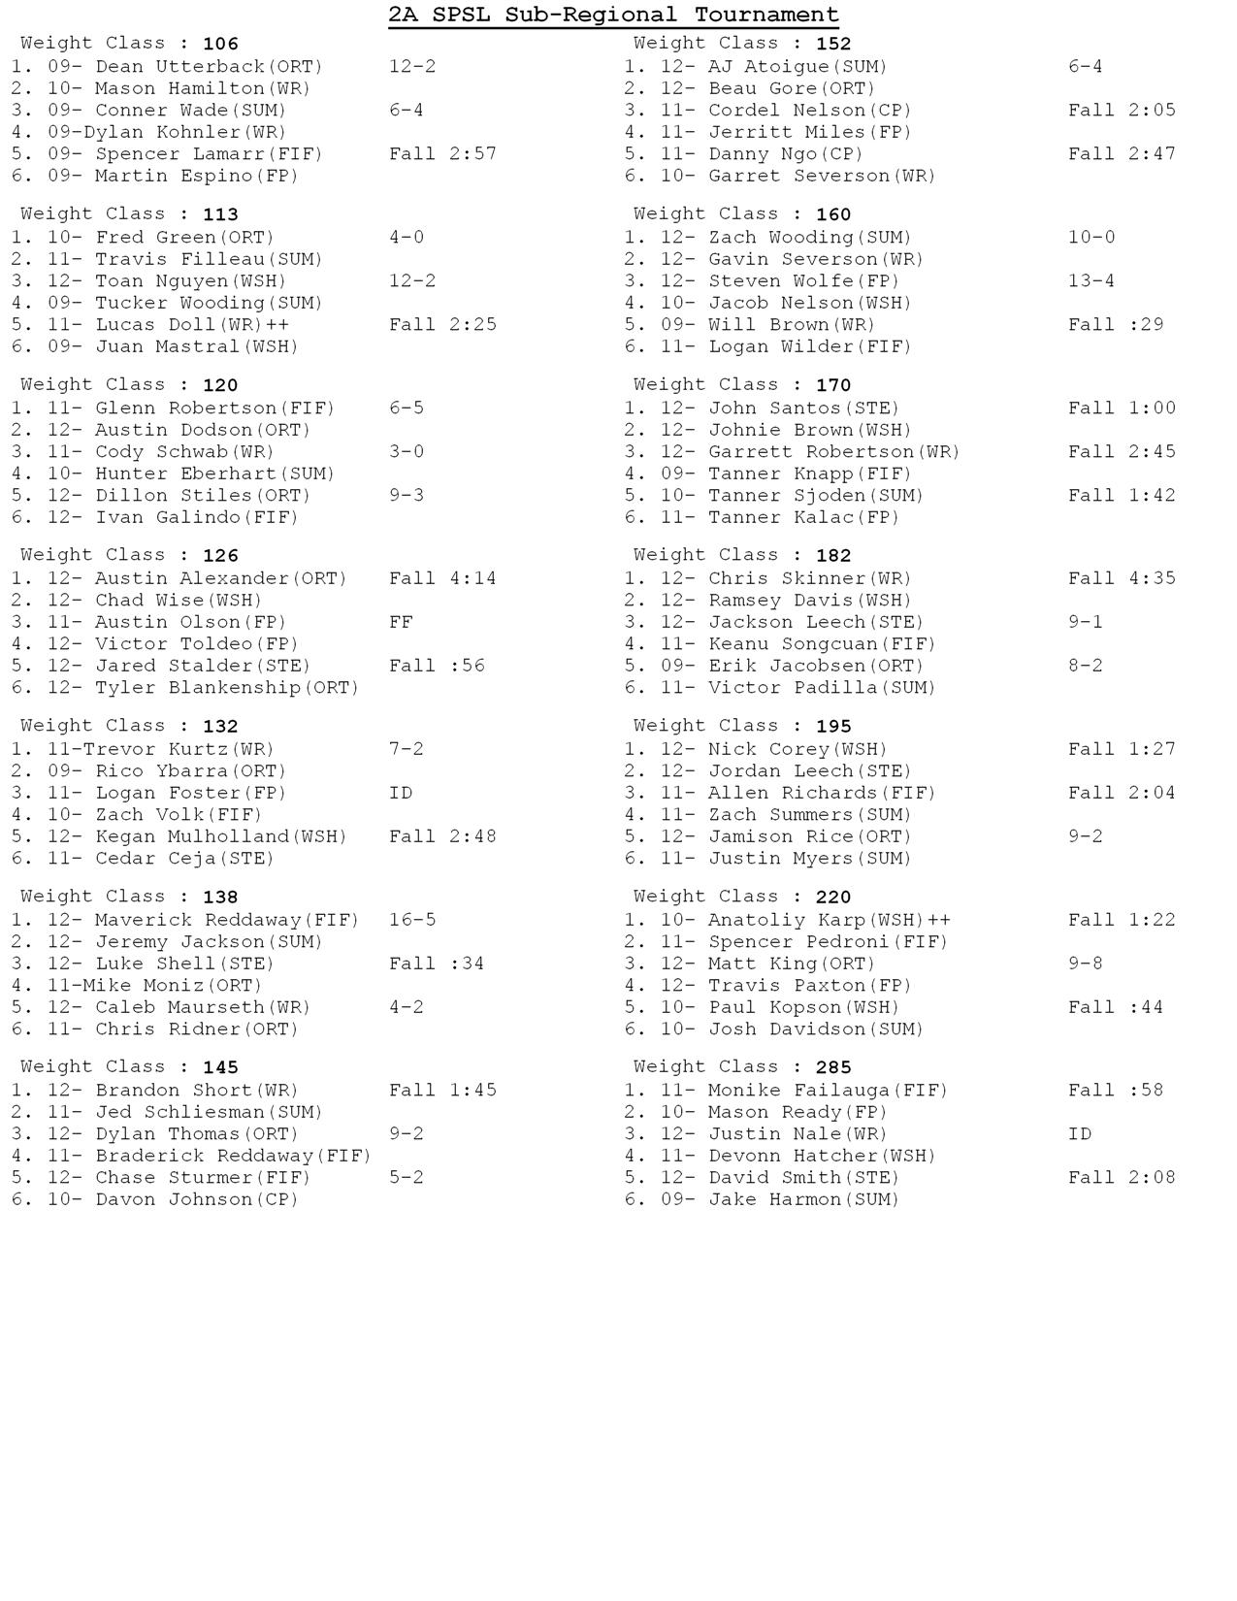

Saturday, February 02, 2013
7:42 PM

Saturday, February 02, 2013
7:43 PM

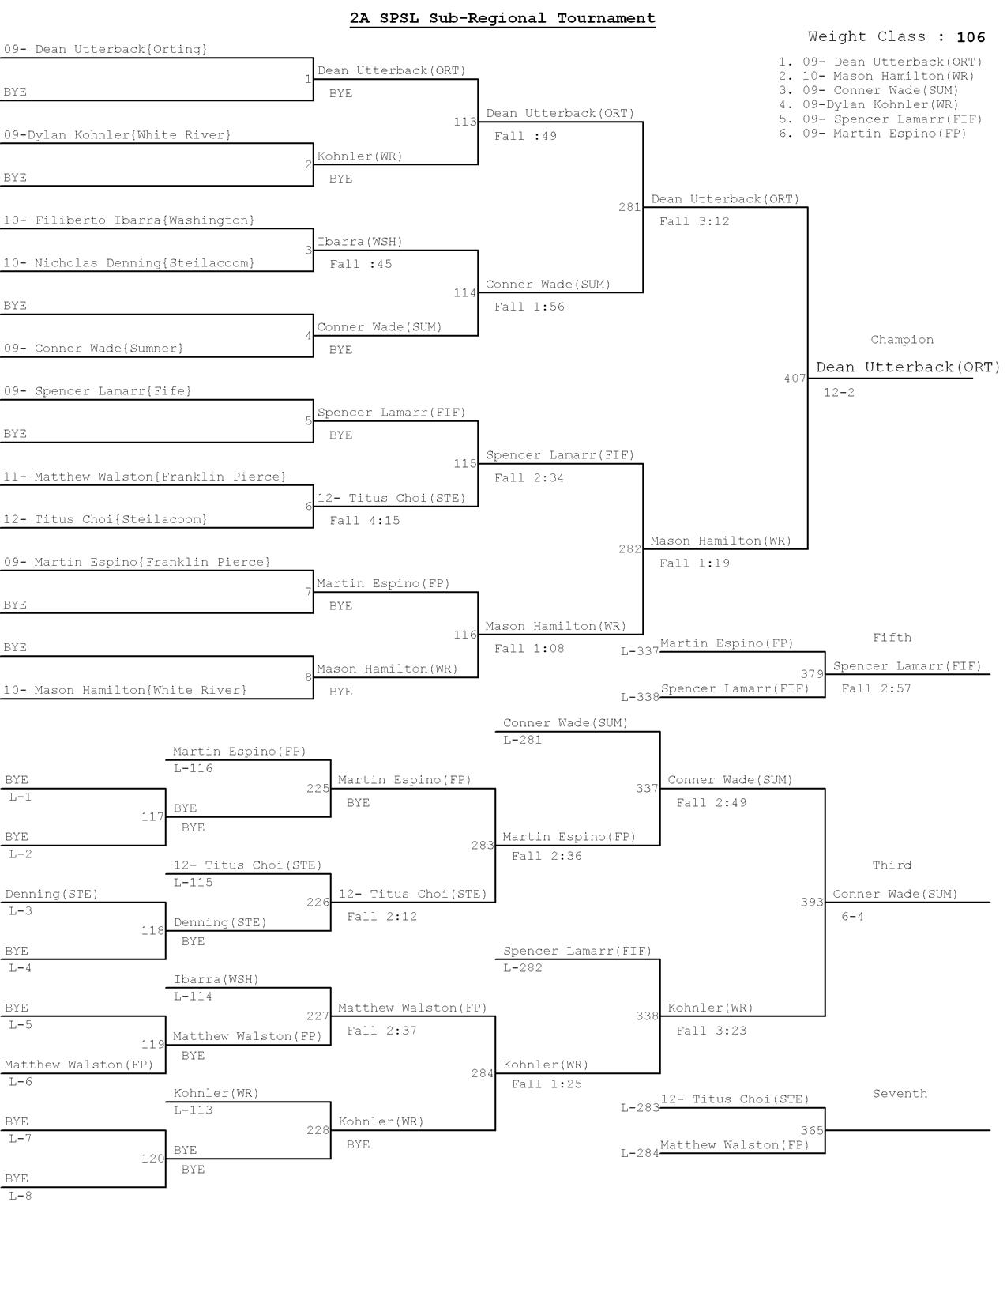

Saturday, February 02, 2013
7:44 PM

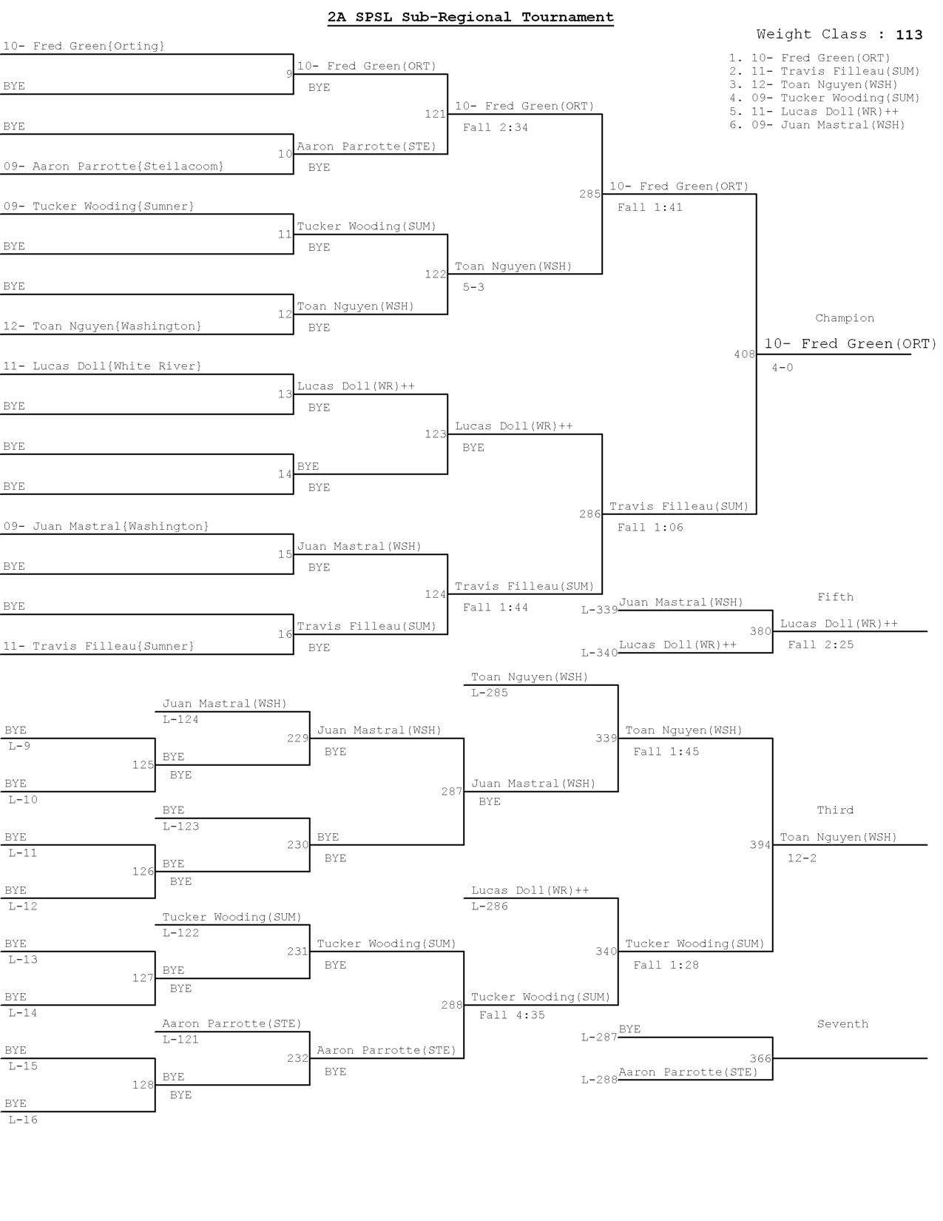

Saturday, February 02, 2013
7:44 PM

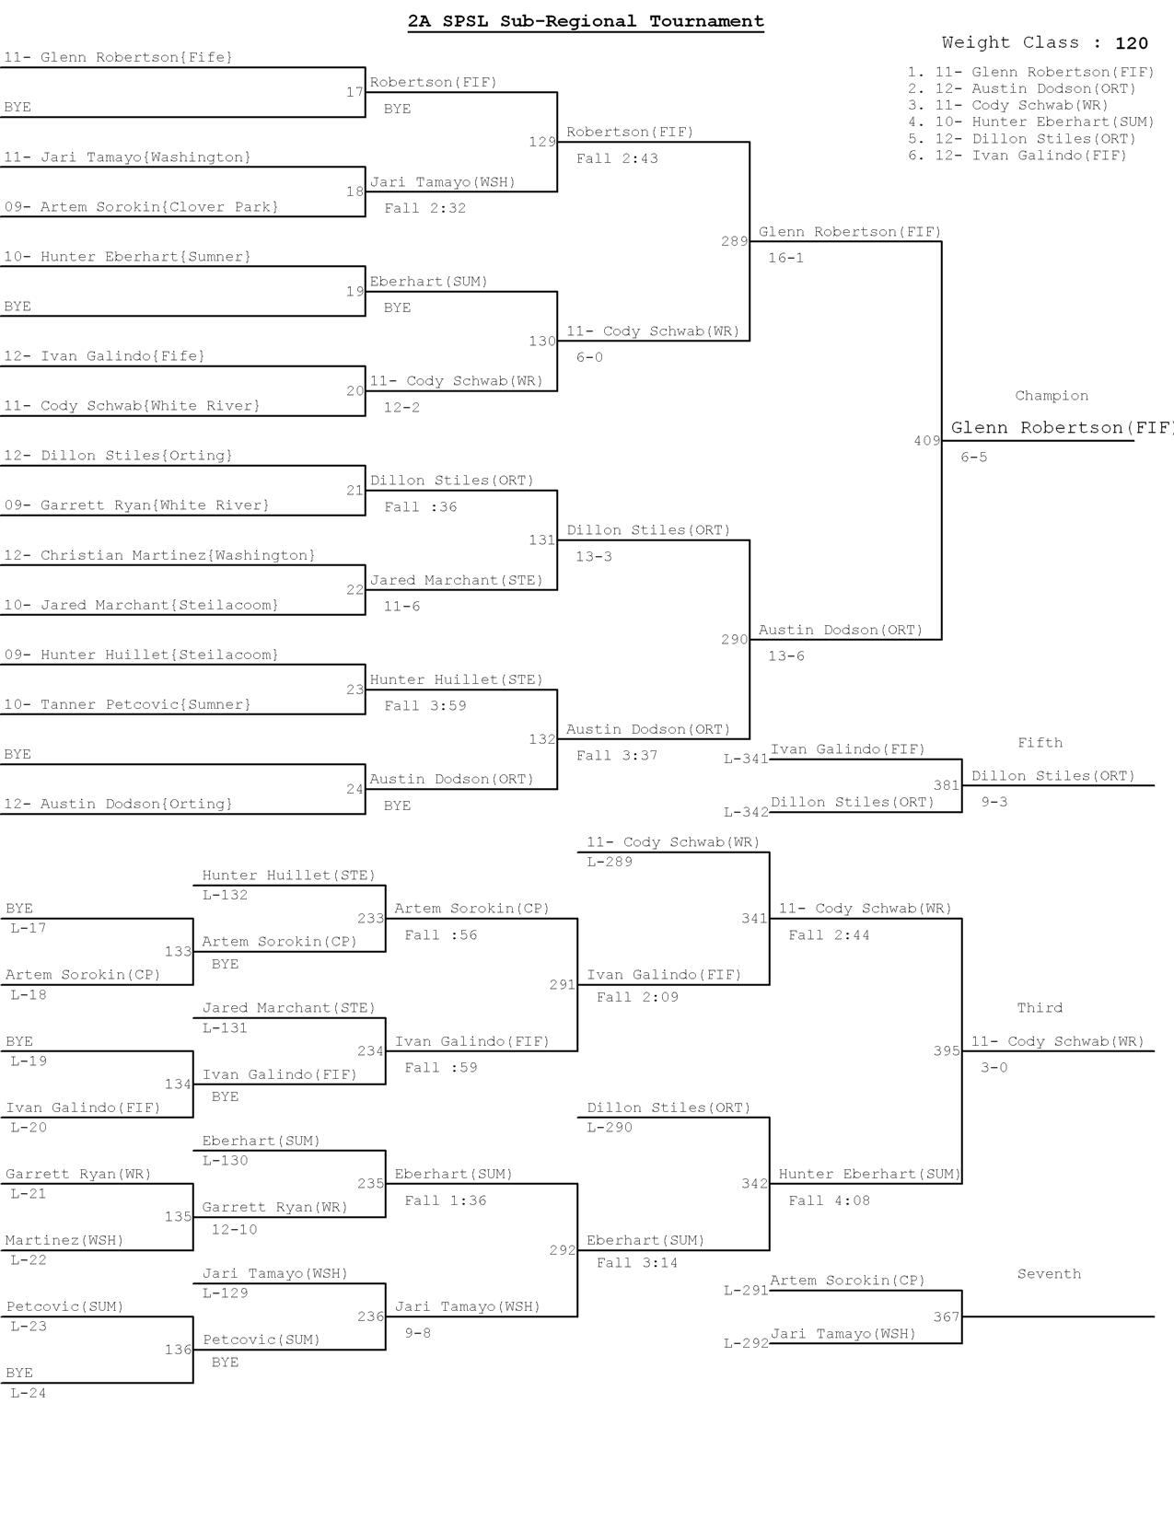

Saturday, February 02, 2013
7:44 PM

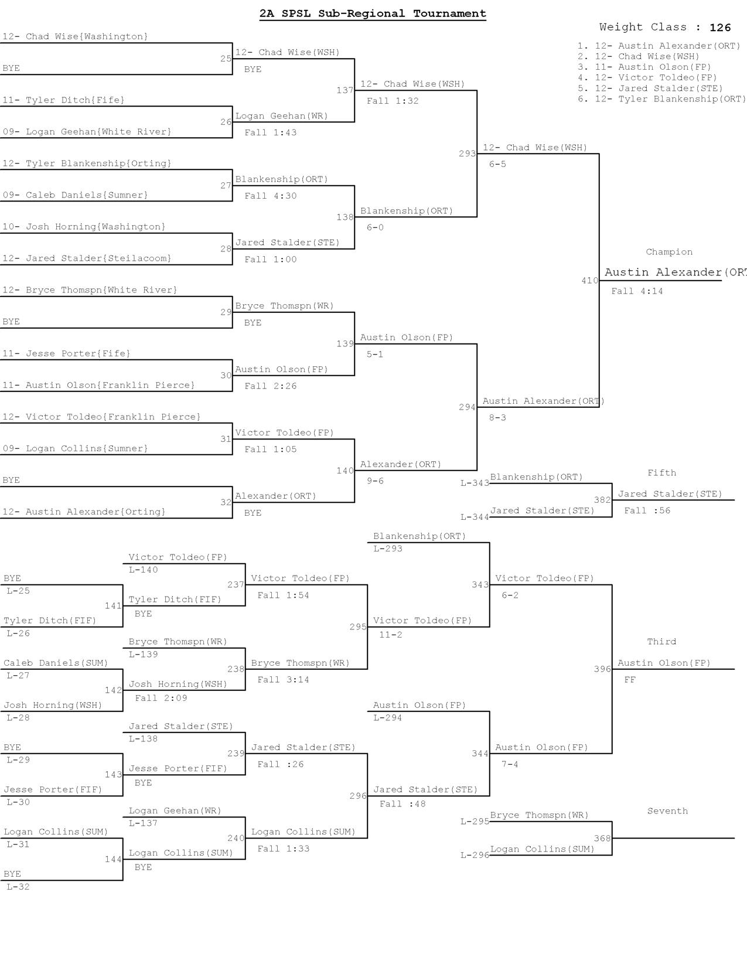

Saturday, February 02, 2013
7:44 PM

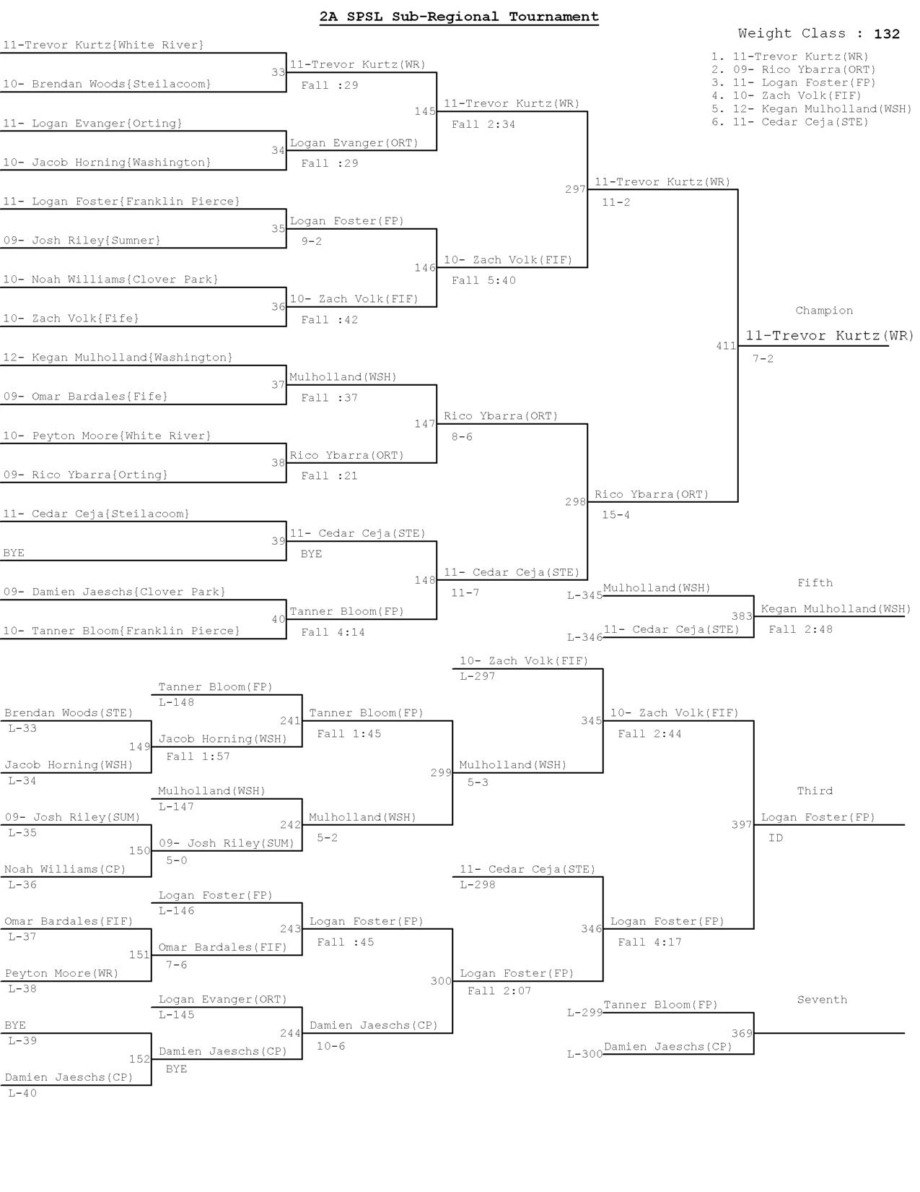

Saturday, February 02, 2013
7:44 PM

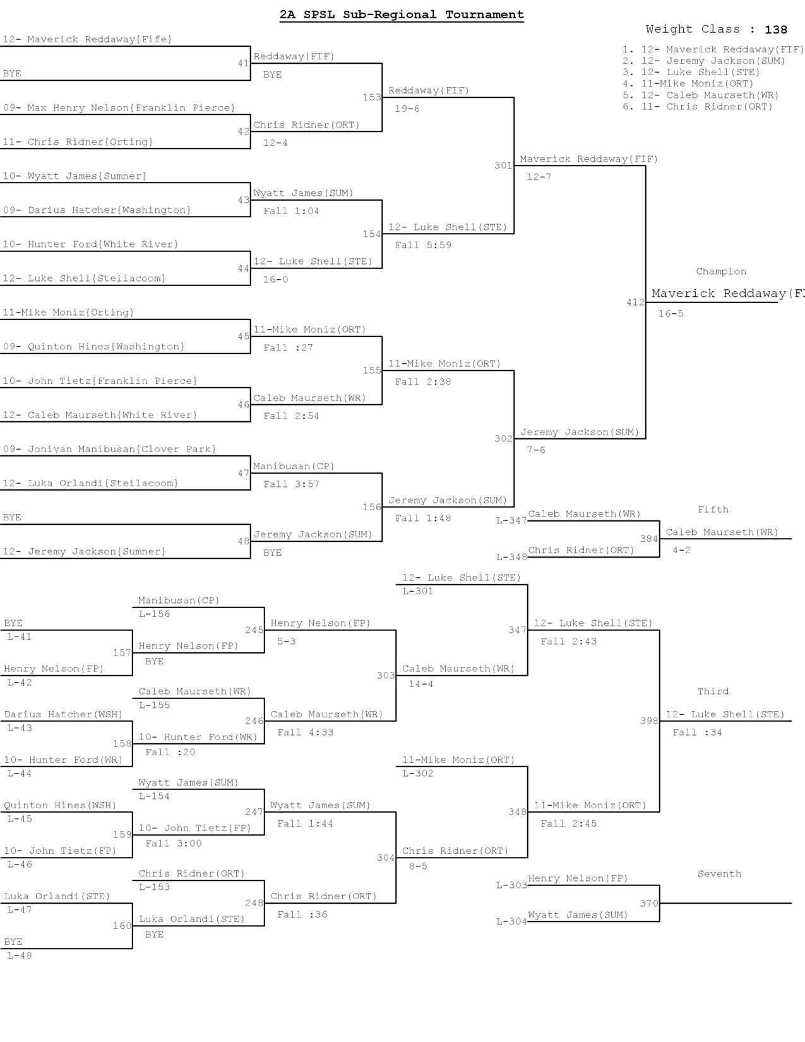

Saturday, February 02, 2013
7:44 PM

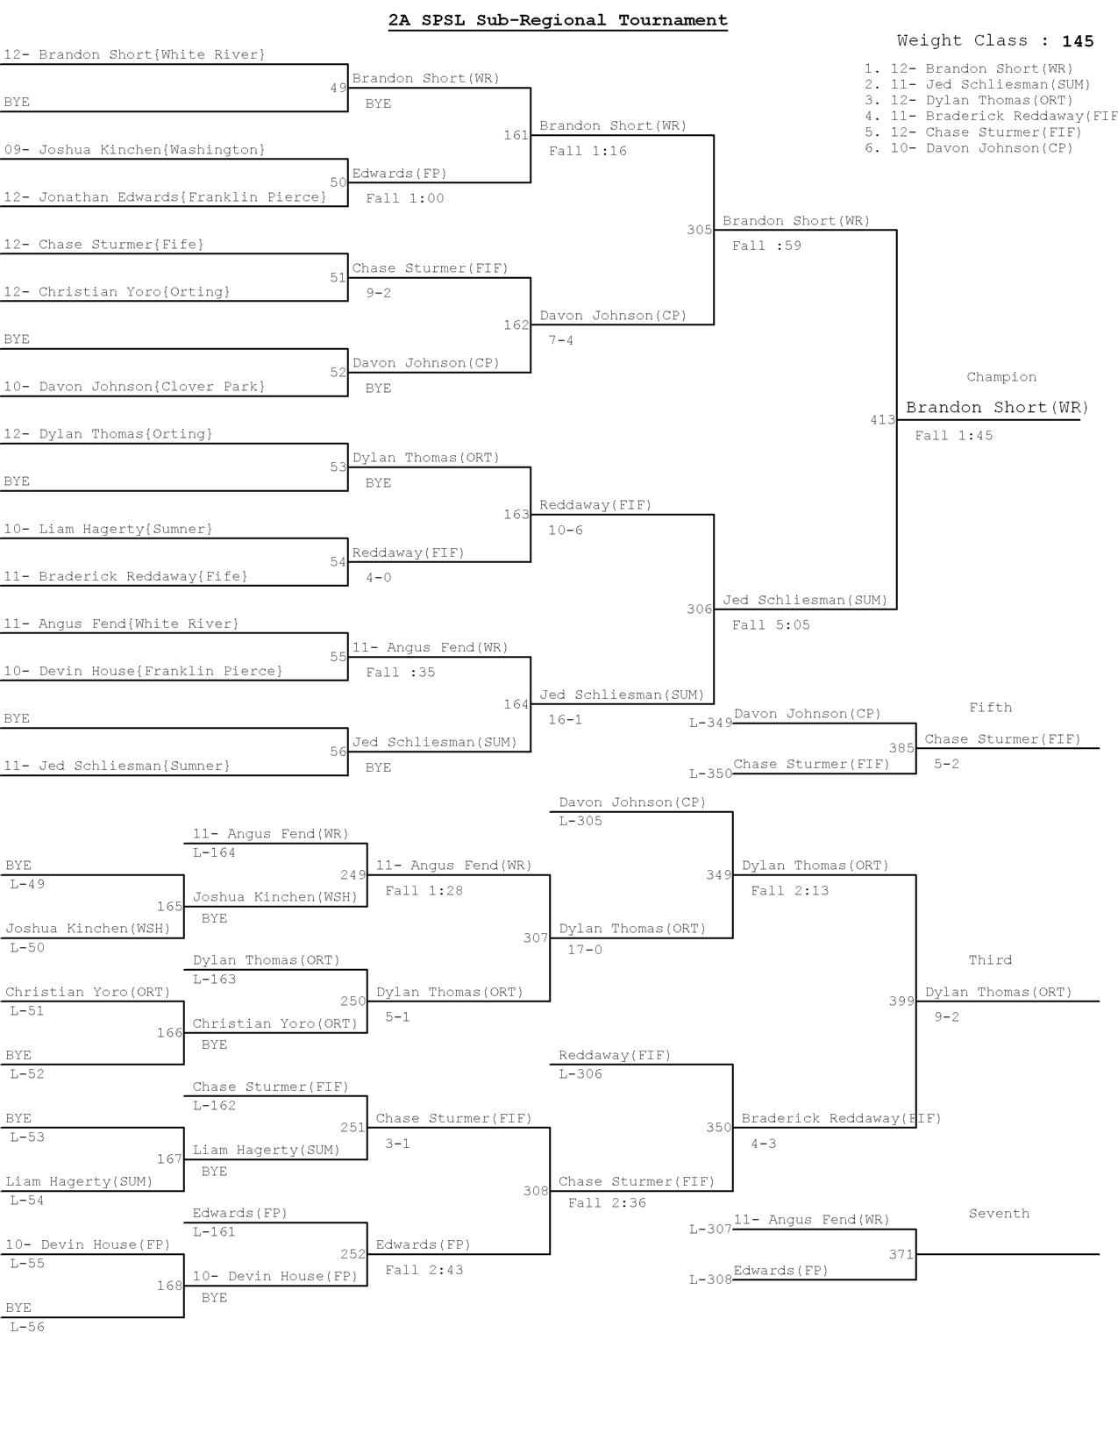

Saturday, February 02, 2013
7:44 PM

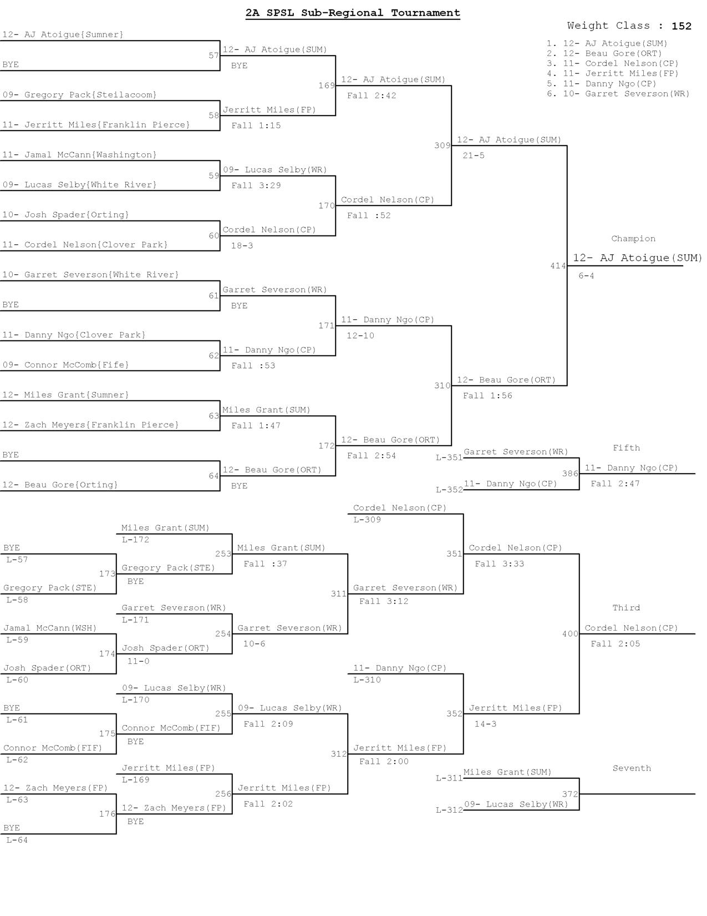

Saturday, February 02, 2013
7:44 PM

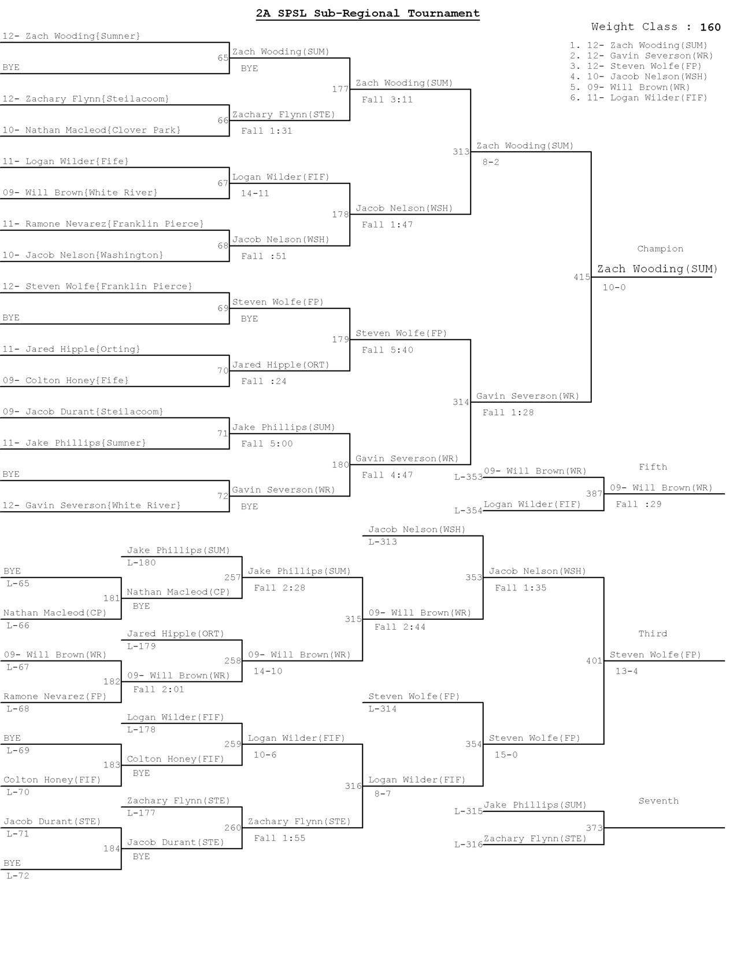

Saturday, February 02, 2013
7:44 PM

