Saturday, February 02, 2013
7:37 PM

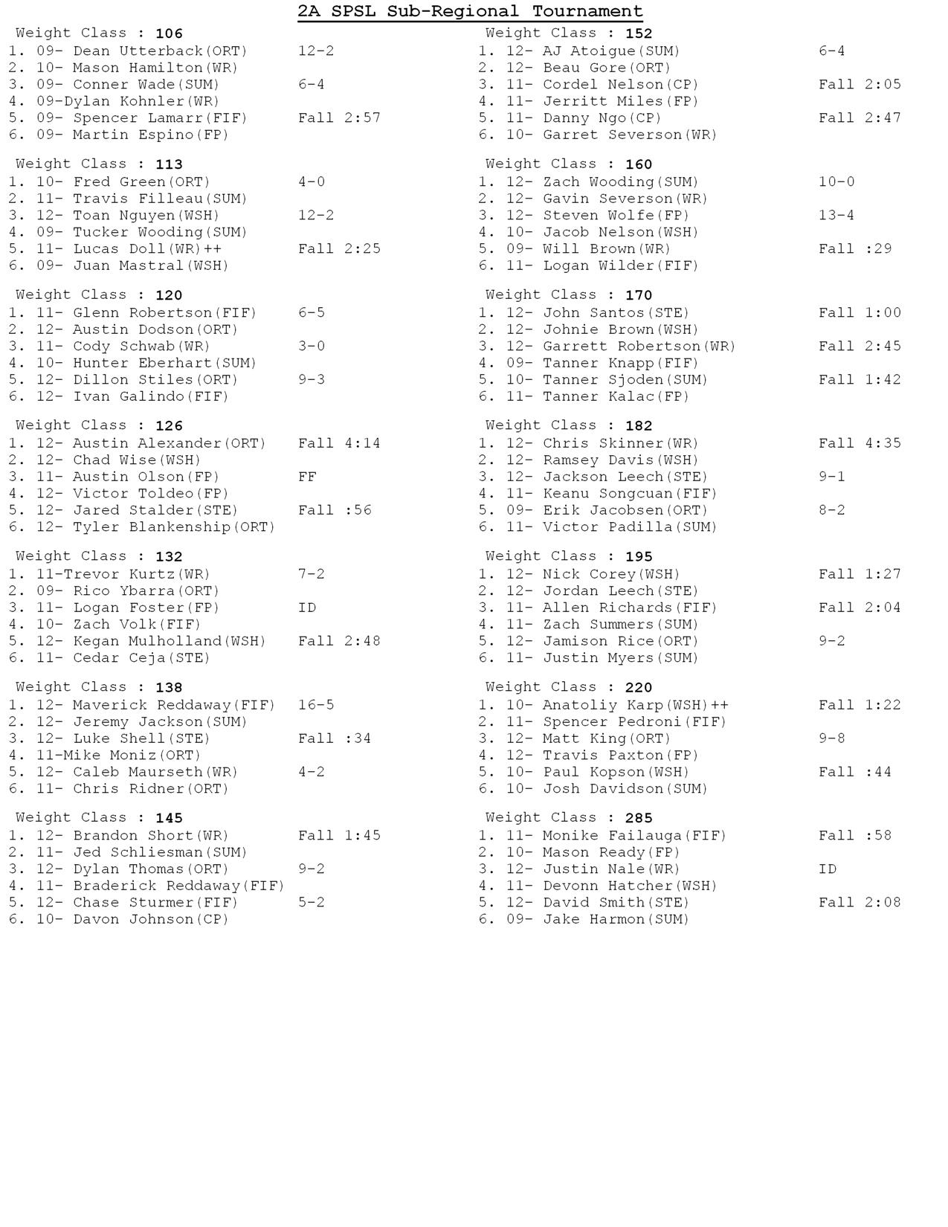

Saturday, February 02, 2013
7:42 PM

